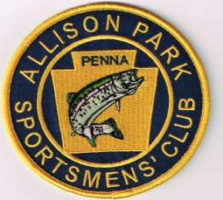

**ALLISON PARK SPORTSMEN’S CLUB**

MEMBERSHIP APPLICATION

PLEASE PRINT *REQUIRED

NAME* _____________________________________ BIRTH DATE _________________

ADDRESS* ________________________________________________________________

CITY, ZIP CODE* ____________________________________________________________

EMPLOYER ____________________________________

HOBBIES/INTERESTS ________________________________________________________

SPECIAL SKILLS _____________________________________________________________

HOME PHONE* _________________________________

CELL PHONE* ___________________________________

E-MAIL ADDRESS* ___________________________________________________________

CONSERVATION PLEDGE

I GIVE MY PLEDGE AS AN AMERICAN TO SAVE AND FAITHFULLY DEFEND FROM WASTE THE NATURAL RESOURCES OF MY COUNTRY, THE SOIL, THE WATER, THE AIR, THE MINERALS, THE PLANT LIFE AND THE WILDLIFE. THIS IS MY PLEDGE.

MEETINGS

**Elfinwild Fire Hall 2807 Mt. Royal Boulevard Glenshaw, PA 15116**

3RD THURSDAY OF MONTH @ 7:00 PM (NO MEETINGS IN JUNE, JULY or AUGUST)

DUES $25.00 PER YEAR

SIGNATURE* _________________________________DATE* ________________Glenshaw, PA 15116OFFICERS

STEPHEN PLUT PRESIDENT 412-956-0539

BILL GRUBBS VICE PRESIDENT 412-992-0279

SAM BACCO TREASURER 412-372-6826

GARY FRANCESCHINA SECRETARY 412-364-2436

Website: <https://www.allisonparksportsmensclub.org>

Email: www.AllisonParkSportsmensClub@Gmail.com